**For SRS**

https://help.hackerearth.com/hc/en-us/categories/360000356113-Assessments-Candidates

**Test customization**

Recruiters may also customize the test in the following ways:

**Disable copy and paste in the code editor**

This does not allow you to copy the code from somewhere on the web or a local computer and paste it into the editor.

**Disable copying of the problem statement**

This prevents you from copying the problem statement from the editor onto any online portal.

**Remote monitoring**

When the test is live, you will be monitored remotely by the recruiter. Tests with this setting require you to have an active webcam.You will not be able to take the test if your:

* Computer does not have a working webcam
* Webcam is not switched on

**Full-screen mode**

Recruiters can make it mandatory to take the test in full-screen mode only. If you exit the full-screen mode, a warning will be displayed on the screen

**Logging out on switching tabs**

This is HackerEarth Recruit's most stringent proctoring setting yet. When you are in the test environment, you will not be allowed to move out of the test screen. Each time you move out, the system gives you a warning and subsequently logs you out. The system considers the following as switching tabs:

* Moving to a new window/tab
* Opening a new application from your computer including system pop-ups like antivirus, Lync, Skype etc.  
    
  *Note*: It is recommended that you disable system updates before beginning the test.

# **Supported browsers and languages**

<https://help.hackerearth.com/hc/en-us/articles/4402703137945-Supported-browsers-and-languages>

HackerEarth Assessment supports the following browsers (up to the last 2 versions):

* Mozilla Firefox
* Google Chrome
* Edge
* Safari

HackerEarth Assessment allows you to code in multiple languages.

**Note**: The languages that you are allowed to code during a test are based on the languages that the test admin has set while creating the test.

The languages that are supported include the following.

Notes

* X - Time limit will be mentioned in the problem statement.
* The maximum memory limit is 256 MB.

|  |  |  |
| --- | --- | --- |
| **S. No.** | **Language** | **Version** |
| 1 | Bash | 5.X |
| 2 | C | gcc 11.X |
| 3 | C++ | C++17 (gcc 11.X) |
| 4 | C# | C# 8.0 (mono 6.X) |
| 5 | Clojure | 1.10.X |
| 6 | D | DMD 2.097.0 |
| 7 | Erlang | ERTS 12.0 |
| 8 | F# | F# 5.0 |
| 9 | Go | go 1.16.5 |
| 10 | Groovy | 3.0.8 |
| 11 | Haskell | 9.0.1 |
| 12 | Java | javac 1.8.0_241 |
| 13 | Java 8 | javac 1.8.0_131 |
| 14 | Java 14 | Java 16 |
| 15 | JavaScript (Node.js) | v16.4.0 |
| 16 | Julia | v1.6.1 |
| 17 | Kotlin | 1.5.20 |
| 18 | Lisp | csc 4.12.0 (rev 6ea24b6) |
| 19 | Lisp (SBCL) | 2.1.5 |
| 20 | Lua | 5.4.3 |
| 21 | Objective C | clang version 12.0.0 |
| 22 | OCaml | 4.12.0 |
| 23 | Octave | 6.2.0 |
| 24 | Pascal | 3.2.2 |
| 25 | Perl | 5.34.0 |
| 26 | PHP | 7.4.20 |
| 27 | Python | 2.7.18 |
| 28 | Python 3 | Python 3.5.2 |
| 29 | Python 3.8 | 3.9.5 |
| 30 | R (RScript) | 4.1.0 |
| 31 | Racket | v8.1 |
| 32 | Ruby | 3.0.1 |
| 33 | Rust | 1.53.0 |
| 34 | Scala | 2.12.14 |
| 35 | Swift | swift 4.1 and 5.4.1 |
| 36 | Typescript | tsc 4.3.2 |
| 37 | Visual Basic | mono 6.12.0 |

# **Administrator dashboard**

<https://help.hackerearth.com/hc/en-us/articles/360003352433-Administrator-dashboard>

The administrator dashboard allows you to view your tests, questions library, FaceCode, and ongoing tests.

This page summarizes your account details, including live tests, live interviews, and previously-conducted tests.

This is what the dashboard of your HackerEarth Recruit account looks like:

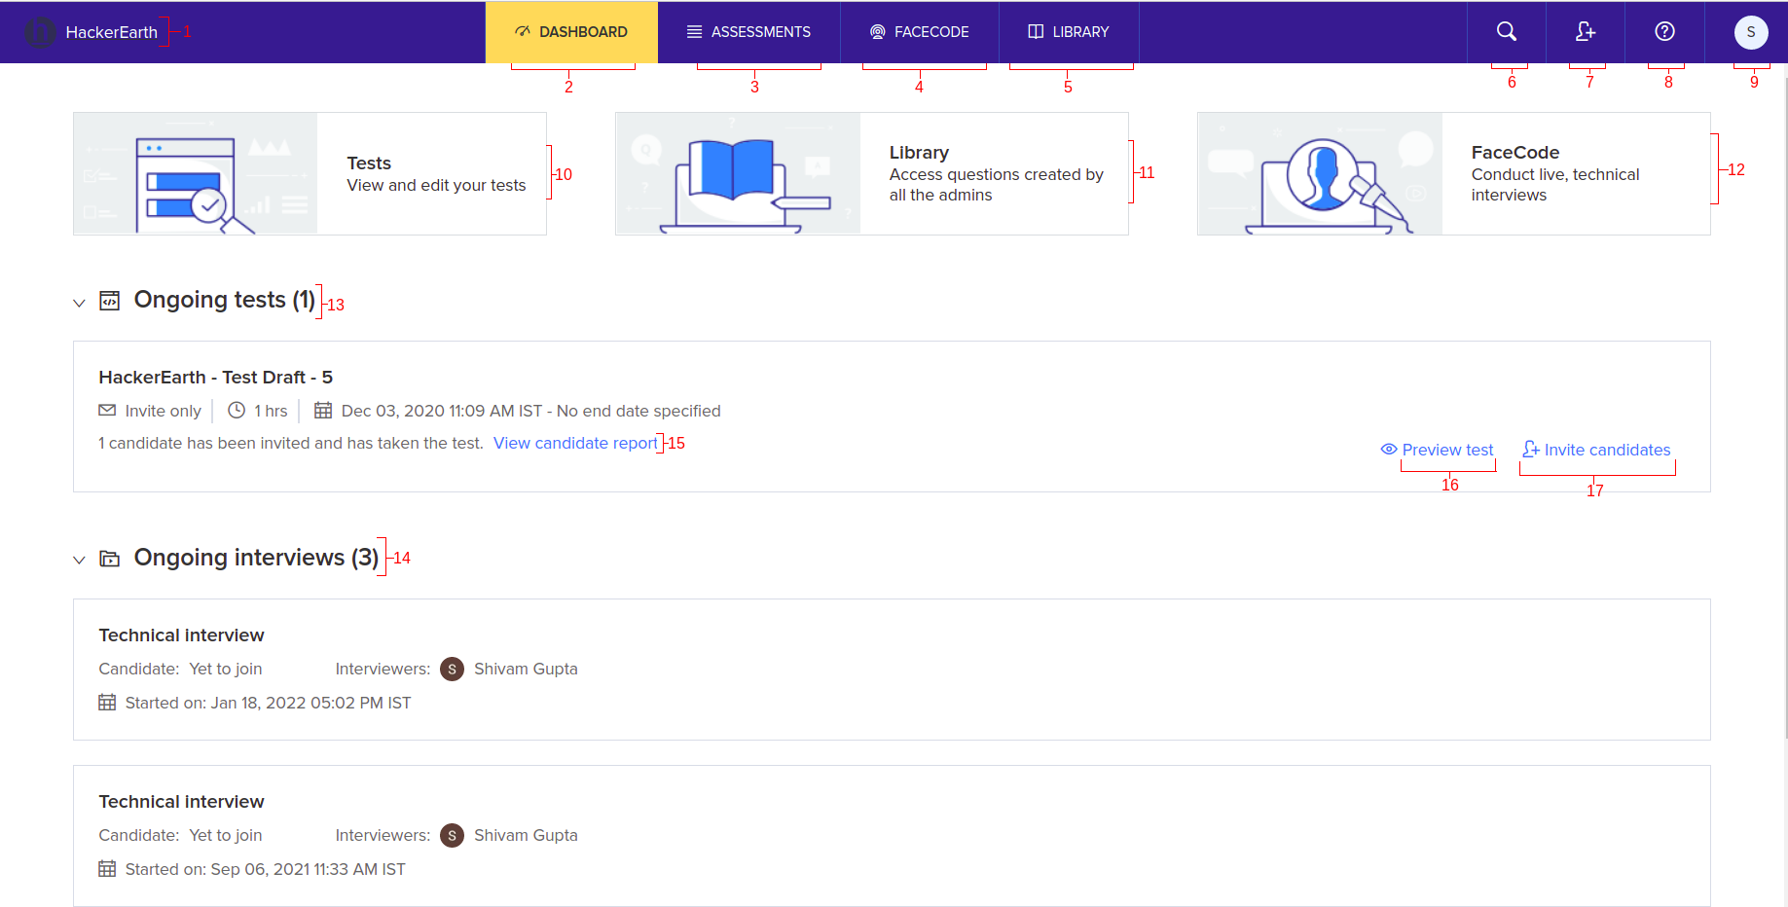

|  |  |  |
| --- | --- | --- |
| **S.No**. | **Title** | **Explanation** |
| 1 | HackerEarth | This button redirects you to the Administrator dashboard if you are on some other tab or section. |
| 2 | Dashboard | This button redirects you to the Administrator dashboard. |
| 3 | Assessments | This button will open up the Assessment dashboard, where you can see all the ongoing tests, search for any test or tag, and create new tests. |
| 4 | FaceCode | This will redirect you to the FaceCode dashboard, where you can see your interviews or create a new one. |
| 5 | Library | This will show you the HackerEarth Library, where you can view the questions and create new questions in My library. |
| 6 | Search candidates | This allows you to search for a particular candidate by entering their name. and you will get a list of all the tests they have taken before. |
| 7 | Add admins | This allows you to add admins to the recruit platform. |
| 8 | Help | This allows you to enter any query related to the Recruit platform. |
| 9 | Your name | When you click this, the following options will be displayed:   * + Settings: Change or update your personal and company information. For more information, see[Settings](https://support.hackerearth.com/hc/en-us/sections/360000843333-Account-settings).   + Billing: Access and complete your billing transactions in HackerEarth Recruit. For more information, see[Billing and usage](https://support.hackerearth.com/hc/en-us/sections/360000843353-Billing-and-usage).   + Watch help videos: You can check all the help videos on Youtube to understand the platform better * Visit support center: This opens up the homepage of HackerEarth’s help center. * Request a Demo: Click this to request a demo on HackerEarth Recruit * Logout: Click this to exit from your account |
| 10 | Tests | Redirects you to the test dashboard |
| 11 | Library | Redirects you to the question library |
| 12 | FaceCode | Redirects you to the interview interface |
| 13 | Ongoing tests | The end date of such tests have not:   * Been specified * Passed   The number of candidates who are currently taking the test and the number of candidates who have completed the test is displayed here. |
| 14 | Ongoing interviews | This shows all the FaceCode interviews which have not been completed because of the following:   * The interviewer didn’t join * The candidate didn’t join |
| 15 | View candidate report | Redirects you to the test dashboard, where you can view the detailed reports of the candidates who have completed your test. |
| 16 | Preview test | You can preview the test and see how the test will look from the candidate’s point of view |
| 17 | Invite candidates | This allows you to invite candidates directly to the test. |